COMPUTING SUBJECT: Webservice IIS and other problems

TYPE: Assignment

IDENTIFICATION: WebserviceProblems

COPYRIGHT: Michael Claudius

LEVEL: Difficult to do, easy to understand

TIME CONSUMPTION: 2-10 hours

EXTENT: 50 lines

OBJECTIVE: Solving various issues

PRECONDITIONS: Sommerville 31.1
Calculator Webservice on localhost

COMMANDS:

IDENTIFICATION: WebserviceProblems

The Mission

There can be quite a lot of issues, when providing/publishing web-services. Help are given in this paper concerning:

Issue 1: port 65080 is not open

Issue 2: .NET v4.0 version cannot be found by IIS.

Issue3: IIS does not have access to the publish directory

Issue 4: IIS cannot be found

Issue 5: .NET and WCF features not selected

Issue 1: Port 65080 is not open for communication
Open port 65080 to accept inbound and outbound TCP-requests.
Choose ControlPanel -> System Security -> Windows Firewall -> Advanced setteing
Then select -> Inbound rules -> Create New Rule
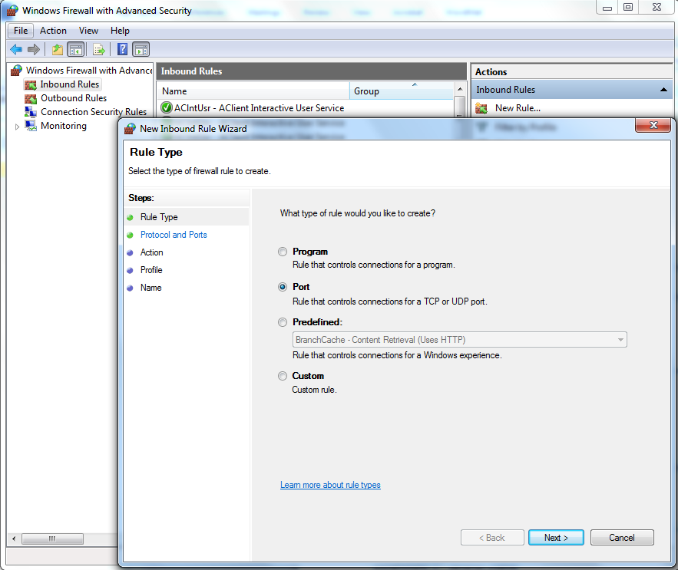

And configure TCP to allow to use port 65080.
Finally do the same for Outbound rules.

Issue 2: IIS cannot find the .NETv4.0 version.
The reason for this problem is that Windows and IIS were installed before .NET 4.0.30319 (probably installed later by Visual Studio or a Windows update). Therefore IIS cannot recognize the correct .NET-version and the result is spooky error messages.
The IIS has its own meta-database of information and therefore we need to run a command so the IIS can see and make use of all installed .NET versions. The name of the command is regiis.

Open Windows explorer (path finder) and find the folder with the last .NET version:

Windows -> Microsoft.NET -> Framework -> v4.0.30319

Right click on C:\Windows\Microsoft.NET\Framework\v4.0.30319
And copy it.

Then open a command prompt and run the command:

>C:\Windows\Microsoft.NET\Framework\v4.0.30319\aspnet_regiis.exe -i

Then try to set up the Web-application again.

Issue 3: IIS does not have access to the publish directory
ISS cannot find/use the published files’ information as the directory for publishing is path privately owned by the user.

Select the directory -> Right click on Properties/Settings
To change permissions: Choose Security -> Edit -> Add

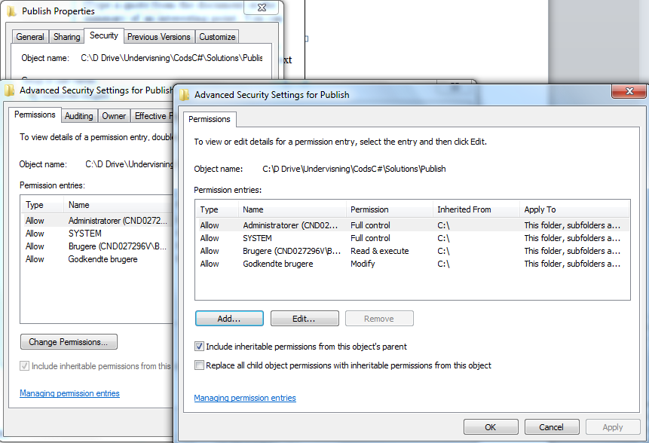

Click -> Locations
Change location to local computer identification like: CND027296V
Click Advanced -> Find Now

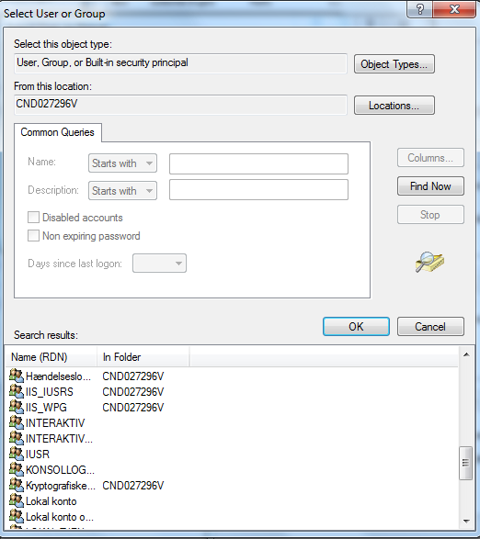

Now Choose two or more IIS objects like: IIS_IUSRS; IIS_WPG; IUSR
Click OK

As a result IIS should now be able to access the publish-directory

If this set up fails then publish the web-service in the same folder as where your project is located.

Issue 4: IIS can not be found
This is because the ISS-program is not turned on.
From Control Panel Choose -> Programs -> Programs and Features -> Turn Windows features on
Wait long time and you will see:

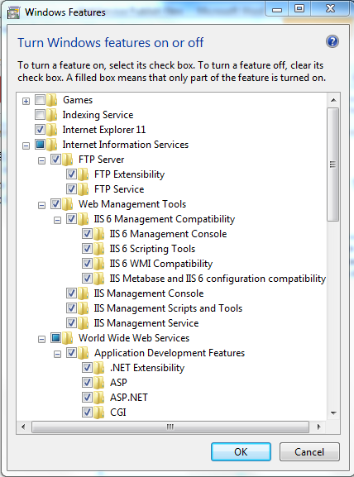

Tick all boxes and also boxes in subfolders Internet Information Services including World Wide Web Services.
Try again. Maybe you need to restart your computer.

Issue 5: .NET and WCF features not selected
This is because some .NET and WCF features have not been turned on
From Control Panel Choose -> Programs -> Programs and Features -> Turn Windows features on
Wait some time and find the .NET features and you will see:

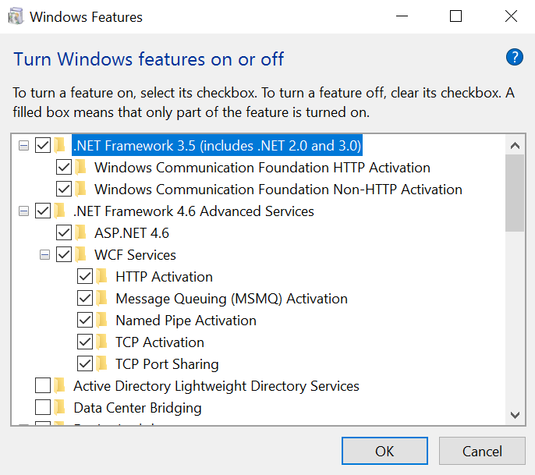

Tick all boxes and also boxes in subfolders, and especially don’t forget the WCF-boxes.
Try again. Maybe you need to restart your computer.

